**Practical-1**

**Aim: WAP to demonstrate example of default constructor or no argument constructor.**

**Program:**

#include<iostream>

#include<string.h>

using namespace std;

class Student

{

private:

int GRID;

char name[100];

int age;

// Default constructor

public:

Student()

{

this->GRID = 6694;

strcpy(this->name,"Vraj");

this->age =19;

}

void getData()

{

cout << "=> GRID :- " << this->GRID << endl

<< "=> Name :- " << this->name << endl

<< "=> Age :- " << this->age << endl << endl;

}

};

int main()

{

Student s1,s2;

s1.getData();

s2.getData();

return 0;

}

**Output:**



**Practical-2**

**Aim: WAP to demonstrate example of parameterized constructor.**

**Program:**

#include<iostream>

#include<string.h>

using namespace std;

class Student

{

private:

int GRID;

char name[100];

int age;

// Parameterised constructor

public:

Student(int GRID, char name[], int age)

{

this->GRID = GRID;

strcpy(this->name , name);

this->age = age;

}

void getData()

{

cout << "=> GRID :- " << this->GRID << endl

<< "=> Name :- " << this->name << endl

<< "=> Age :- " << this->age << endl << endl;

}

};

int main()

{

Student s1(6694,"Vraj",19);

Student s2(6488,"Hardik",18);

Student s3(6739,"Nevin",18);

s1.getData();

s2.getData();

s3.getData();

return 0;

}

**Output:**

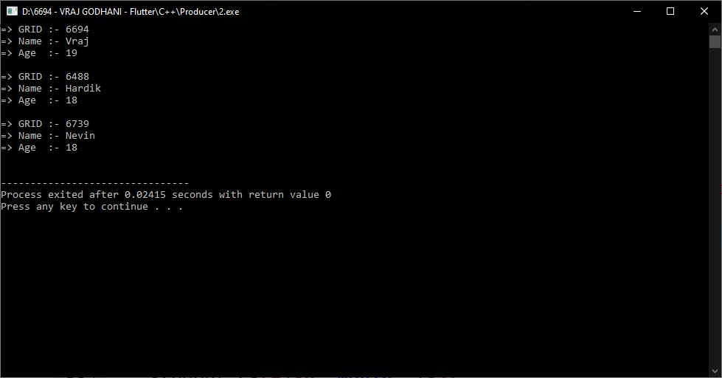

**Practical-3**

**Aim: WAP to create a class which set values of data members using default and parameterized constructor.**

**Program:**

#include<iostream>

#include<string.h>

using namespace std;

class Student

{

private:

int GRID;

char name[100];

int age;

public:

// parameterised constructor

Student(int GRID, char name[], int age)

{

this->GRID = GRID;

strcpy(this->name , name);

this->age = age;

}

// Default constructor

Student()

{

this->GRID = 6739;

strcpy(this->name , "Nevin");

this->age = 18;

}

void getData()

{

cout << "=> GRID :- " << this->GRID << endl

<< "=> Name :- " << this->name << endl

<< "=> Age :- " << this->age << endl << endl;

}

};

int main()

{

Student s1(6694,"Vraj",19);

Student s2(6488,"Hardik",18);

Student s3;

s1.getData();

s2.getData();

s3.getData();

return 0;

}

**Output:**

